**WHAT IS A NETWORK ?**



* In its simplest form, a network is nothing more than “two connected

computers sharing resources with one another.”

* A network in the context of computing , is system of interconnected devices that can communicate with each other and share information or data.
* It is composed of two main aspects:

o **Physical Connection** (wires, cables, wireless media)

o **Logical Connection** (data transporting across the physical media)

**TYPES OF COMPUTER NETWORK**

* PAN (Personal Area Network)
* LAN (Local Aera Network)
* MAN (Metropolitan Area Network)
* WAN (Wide Area Network)
* CAN (Campus Area Network)
* VPN (Virtual Private Network)
* WLAN (Wireless Local Area Network)
* EPN (Enterprise Private Network)
* SAN (Storage Area Network)

**1. Personal Area Network (PAN) :**

* PAN is the most basic type of computer network. It is a type of network designed to connect devices within a short range, typically around one person.
* It allows your personal devices, like smartphones, tablets, laptops, and wearables, to communicate and share data with each other.
* PAN offers a network range of **1 to 10 meters** from person to device providing communication.
* Its transmission speed is very high with very easy maintenance and very low cost.
* *Examples of PAN are Bluetooth connection between a phone and wireless earbuds , Infrared communication between TV and remote.*

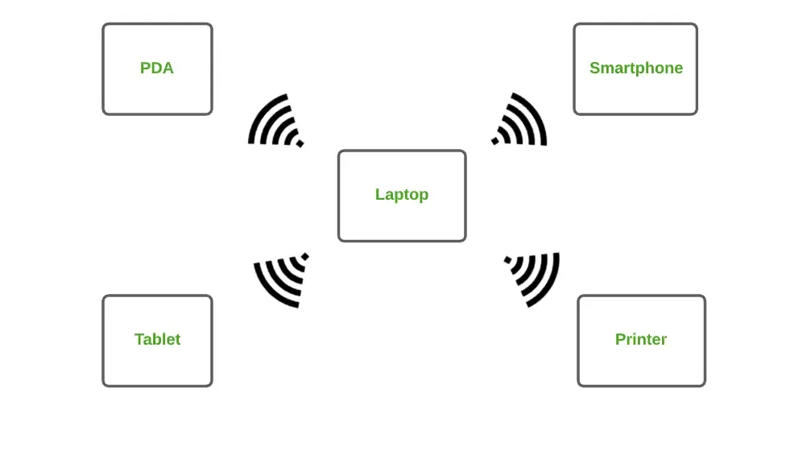

Personal Area Network

**2. Local Area Network (LAN) :**

* LAN is the most frequently used network. It is a computer network that connects computers through a common communication path, contained within a limited area, that is, locally.
* A LAN encompasses two or more computers connected over a server.
* The two important technologies involved in this network are Ethernetand Wi-fi.
* It ranges up to 2km & transmission speed is very high with easy maintenance and low cost.
* *Examples of LAN are Wi-Fi in a home or school, wired LAN in a company's office.*

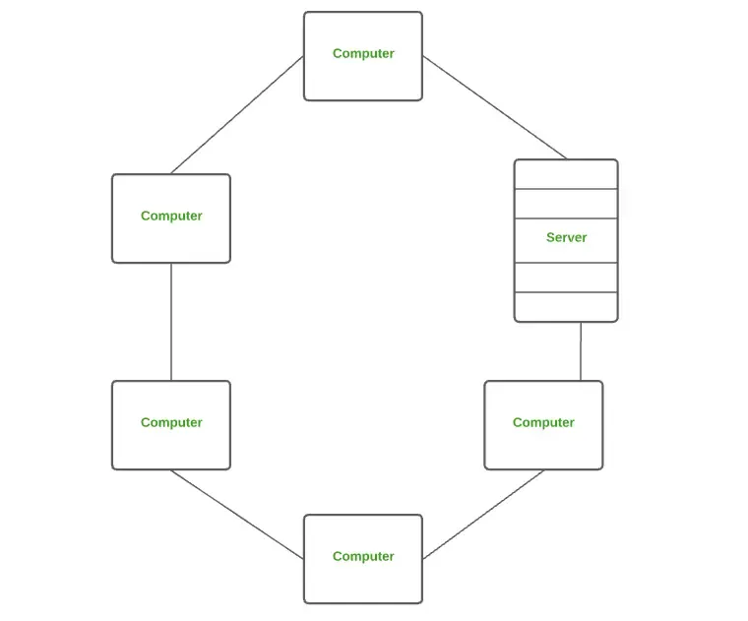

Local Area Network

**3. Campus Area Network (CAN) :**

* CAN is bigger than a LAN but smaller than a MAN. This is a type of computer network that is usually used in places like a school or colleges.
* This network covers a limited geographical area that is, it spreads across several buildings within the campus.
* CAN mainly use Ethernet technology with a range of few kilometers.
* Its transmission speed is very high with a moderate maintenance cost and moderate cost.
* *Examples of CAN are networks that cover schools, colleges, buildings, etc.*

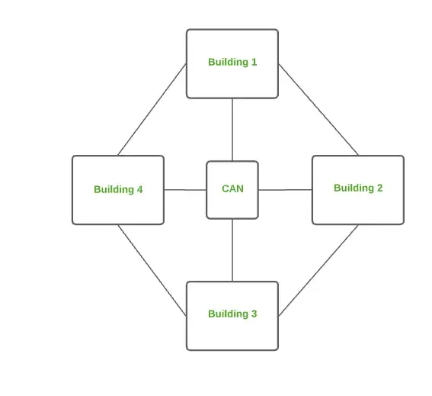

**4. Metropolitan Area Network (MAN) :**

* A MAN is larger than a LAN but smaller than a WAN. This is the type of computer network that connects computers over a geographical distance through a shared communication path over a city, town, or metropolitan area.
* This network mainly uses FDDI, CDDI, and ATM as the technology with a range from **5km to 50km.**
* Its transmission speed is average. It is difficult to maintain and it comes with a high cost.
* *Examples of MAN are networking in towns, cities, a single large city, a large area within multiple buildings, etc.*

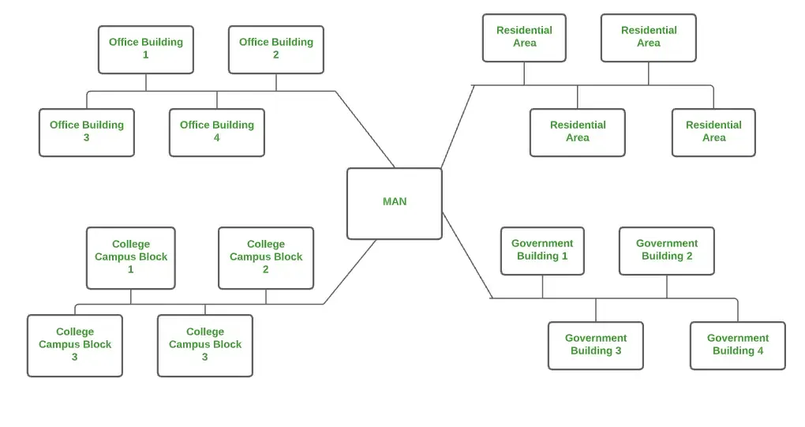

Metropolitan Area Network (MAN)

**5. Wide Area Network (WAN) :**

* WAN is a type of computer network that connects computers over a large geographical distance through a shared communication path.
* It is not restrained to a single location but extends over many locations.
* WAN can also be defined as a group of local area networks that communicate with each other with a range above 50km. Here we use Leased-Line & Dial-up technology.
* Its transmission speed is very low and it comes with very high maintenance and very high cost.
* *Examples of WAN are the Internet (largest WAN), Banking networks linking global branches*

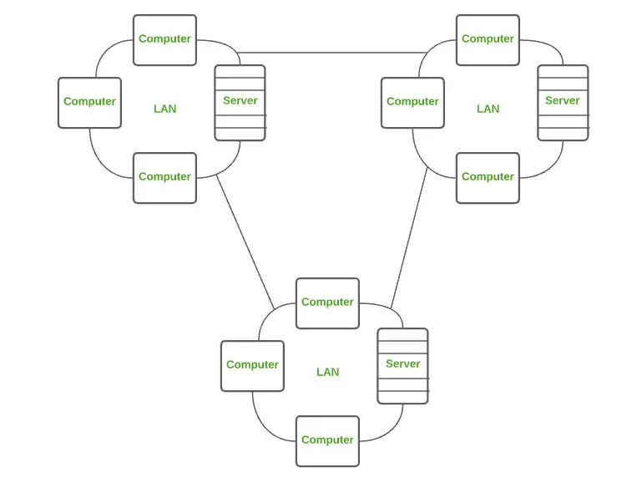

Wide Area Network

**6. Wireless Local Area Network (WLAN) :**

* WLAN is a type of computer network that acts as a local area network but makes use of wireless network technology like Wi-Fi.
* This network doesn't allow devices to communicate over physical cables like in LAN but allows devices to communicate wirelessly.
* *Most common example of WLAN is Wi-Fi.*

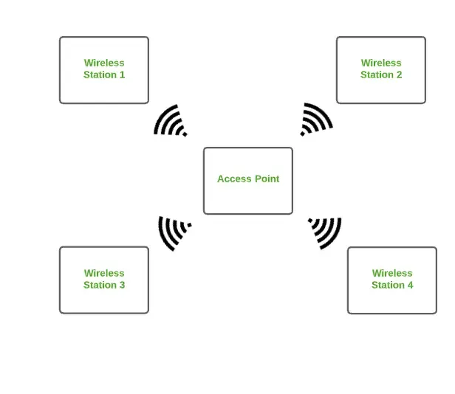

**7. System Area Network (SAN)**

* A System Area Network is designed to connect high-performance computers within a localized, high-speed environment, such as in data centers or supercomputing facilities.
* A SAN provides access to block-level data storage.
* *Examples of SAN are a network of disks accessed by a network of servers.*

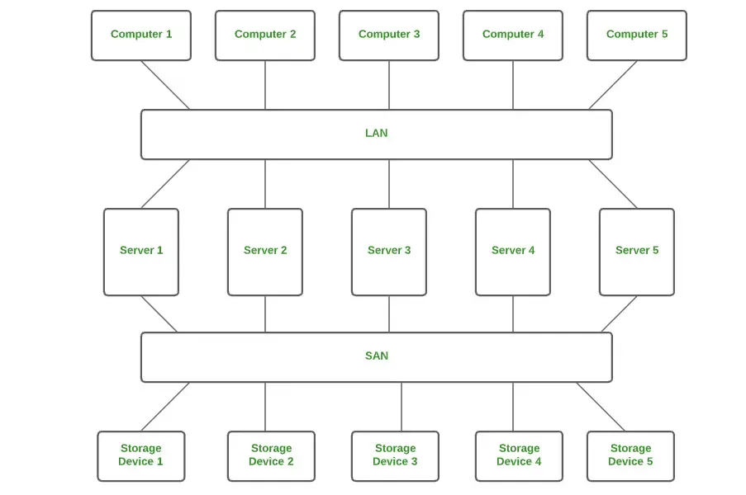

**8. Passive Optical Local Area Network (POLAN)**

* A POLAN is a type of computer network that is an alternative to a LAN.
* POLAN uses optical splitters to split an optical signal from a single strand of single-mode optical fiber to multiple signals to distribute users and devices.
* In short, POLAN is a point to multipoint LAN architecture.

